
TERRAFORM CHALLANGE

Create an EC2 Instance on AWS Cloud using the below-mentioned ubuntu AMI and instance_type. Or, (You can use of your choice as well) ami = "ami-0461b1436c9b3c1a3" instance_type = "t3.micro"
Install a web server on the same EC2 Instance. The web server should listen on port 8080.
Syntax:
resource "aws_instance" "challange" {
ami = "ami-07ff62358b87c7116"
instance_type = "t3.micro"
key_name = "sshless"
security_groups = ["default"]

tags = {
Name = "ChallangeInstance"
}
user_data = <<-EOF
#!/bin/bash
sudo yum update -y
sudo yum install -y httpd
sudo systemctl start httpd
sudo systemctl enable httpd
echo "Hello, World! from TECHIE HORIZON" > /var/www/html/index.html
sed -i 's/Listen 80/Listen 8080/' /etc/httpd/conf/httpd.conf
sudo systemctl restart httpd
sudo systemctl start httpd
EOF

}
output "aws_instance_public_ip" {
value = aws_instance.challange.public_ip
}

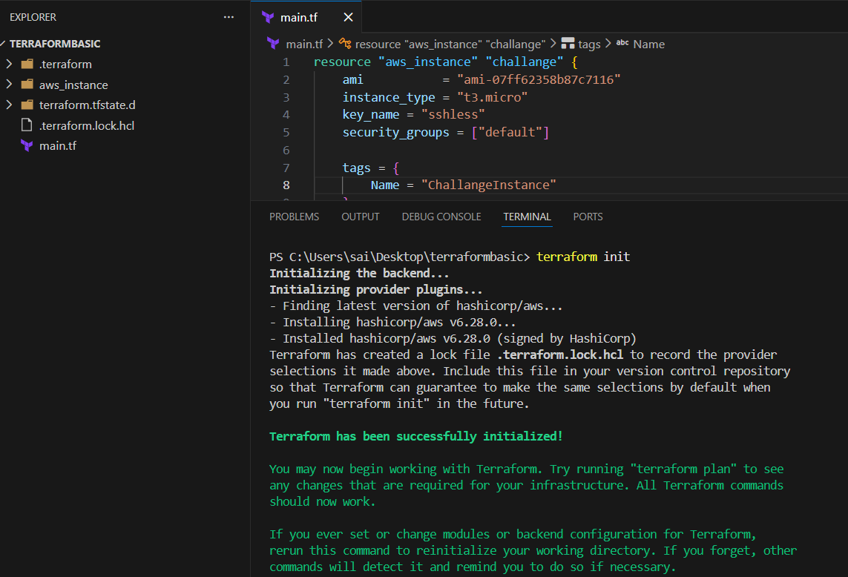

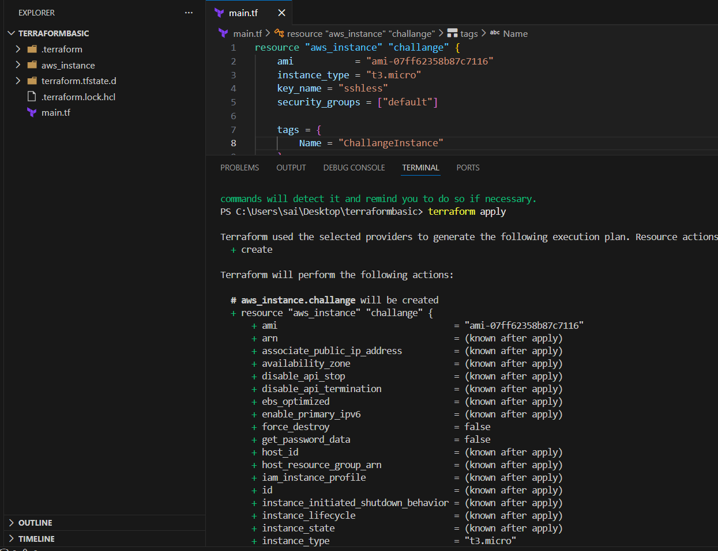
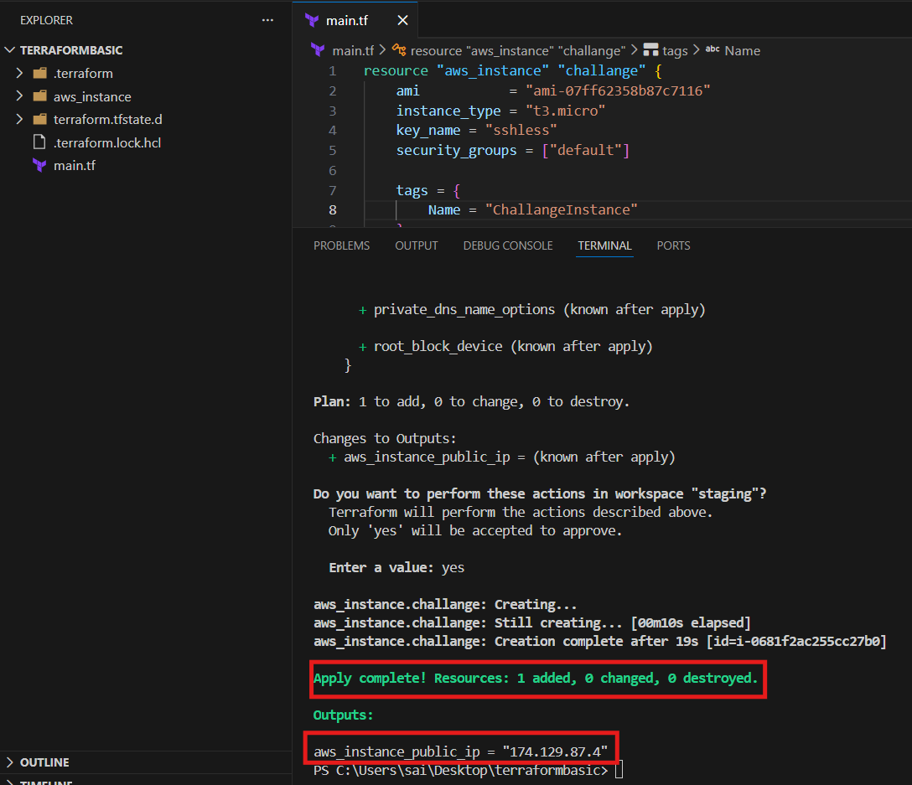
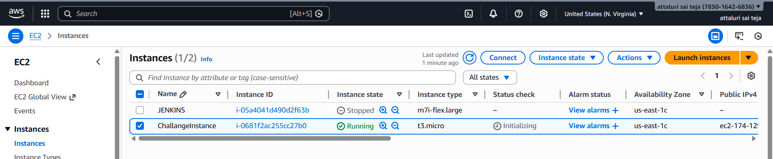
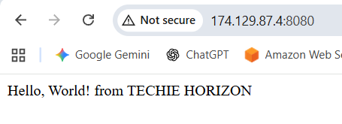.

• Create a Docker-compose file for the project: https://github.com/betawins/cricbuzz-docker-hello-world.git and point it to port 8000.
• Make the web server point to the above service so that 8080 returns the response from the Docker service.
Syntax :
provider "aws" {
region = "us-east-1"
}

# -------------------------
# Key Pair (uses your local public key)
# -------------------------
resource "aws_key_pair" "cb_key" {
key_name = "cb-key"
public_key = file("~/.ssh/id_rsa.pub")
}

# -------------------------
# Security Group (Allow SSH + 8080 + 8000)
# -------------------------
resource "aws_security_group" "cb_sg" {
name = "cb-sg"
description = "Allow SSH and app ports"

ingress {
description = "SSH"
from_port = 22
to_port = 22
protocol = "tcp"
cidr_blocks = ["0.0.0.0/0"]
}

ingress {
description = "Nginx Reverse Proxy Port"
from_port = 8080
to_port = 8080
protocol = "tcp"
cidr_blocks = ["0.0.0.0/0"]
}

ingress {
description = "Docker App Port"
from_port = 8000
to_port = 8000
protocol = "tcp"
cidr_blocks = ["0.0.0.0/0"]
}

egress {
description = "Allow all outbound"
from_port = 0
to_port = 0
protocol = "-1"
cidr_blocks = ["0.0.0.0/0"]
}
}

# -------------------------
# EC2 Instance
# -------------------------
resource "aws_instance" "cb_ec2" {
ami = "ami-0b6c6ebed2801a5cb" # Ubuntu Server 22.04 LTS (HVM), SSD Volume Type
instance_type = "t3.micro"
key_name = aws_key_pair.cb_key.key_name
vpc_security_group_ids = [aws_security_group.cb_sg.id]

user_data = <<-EOF
#!/bin/bash
set -e

apt-get update -y

# Install packages
apt-get install -y docker.io docker-compose nginx git logrotate

systemctl enable docker
systemctl start docker

systemctl enable nginx
systemctl start nginx

# Clone project
cd /opt
rm -rf cricbuzz-docker-hello-world || true
git clone https://github.com/betawins/cricbuzz-docker-hello-world.git
cd cricbuzz-docker-hello-world

# Create docker-compose file (App runs on 8000)
cat > docker-compose.yml <<EOL
version: "3.8"
services:
cb-app:
image: nginx:alpine
container_name: cb-app
ports:
- "8000:80"
restart: always
EOL

# Start docker container
docker-compose up -d

# Nginx reverse proxy config (8080 -> 8000)
rm -f /etc/nginx/sites-enabled/default

cat > /etc/nginx/sites-available/cb-proxy <<EOL
server {
listen 8080;

access_log /var/log/cb.log;
error_log /var/log/cb.log;

location / {
proxy_pass http://127.0.0.1:8000;
proxy_set_header Host \$host;
proxy_set_header X-Real-IP \$remote_addr;
proxy_set_header X-Forwarded-For \$proxy_add_x_forwarded_for;
}
}
EOL

ln -s /etc/nginx/sites-available/cb-proxy /etc/nginx/sites-enabled/cb-proxy

systemctl restart nginx

# Logrotate config for /var/log/cb.log
cat > /etc/logrotate.d/cb-log <<EOL
/var/log/cb.log {
daily
rotate 7
compress
missingok
notifempty
create 0644 root root
sharedscripts
postrotate
systemctl reload nginx > /dev/null 2>/dev/null || true
endscript
}
EOL
EOF

tags = {
Name = "cb-ec2"
}
}

output "ec2_public_ip" {
value = aws_instance.cb_ec2.public_ip
}
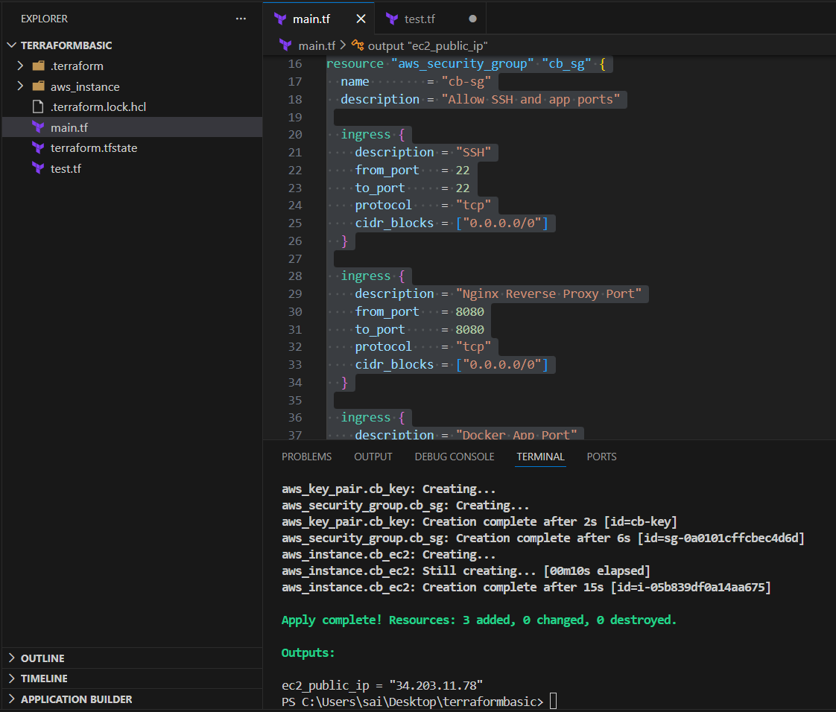
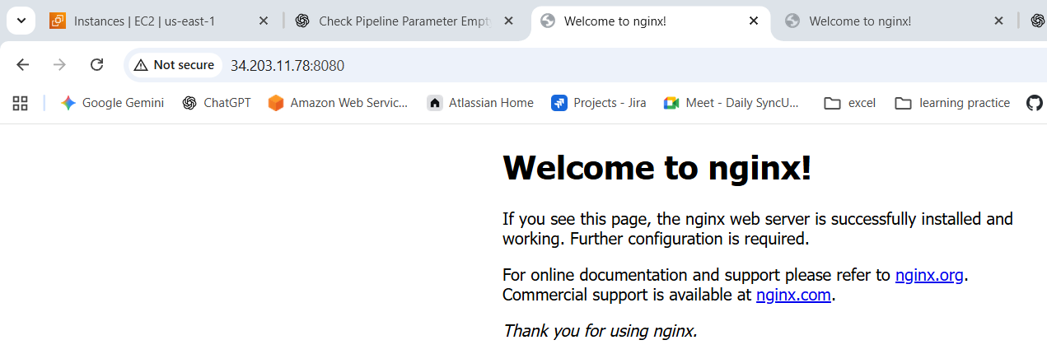
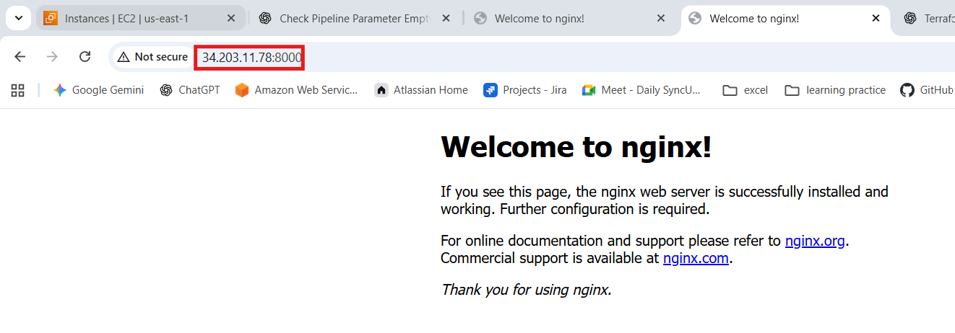
• Configure to Save the Logs in the location /var/log/cb.log
Log in to instance and execute commands
Cat /var/log/cb.log

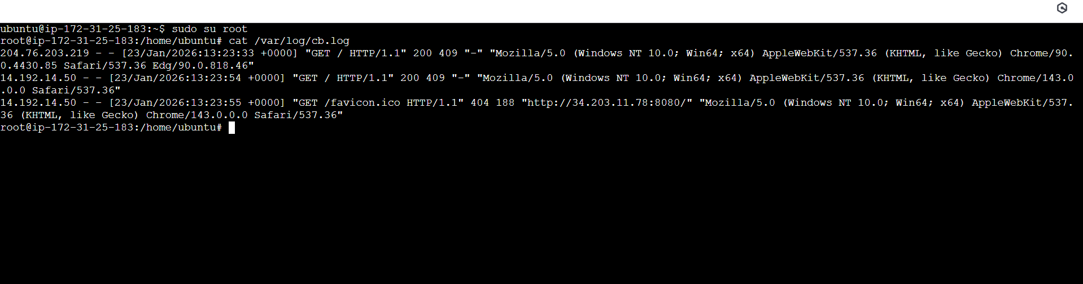

• Write the Log rotate configuration for the above file
For log rotations
Change the directory to /etc/logrotate.d/
And then
Cat cb-log
